Assignment 1

PART I: Confirm UNT Student Email Address (10 Points)
Answer: I have successfully completed the email verification, and I have sent an email to Dr. Nguyen, Thuan from my UNT email id.

PART II: Select an Operating System (10 Points)
Answer: I use a windows machine, and I am comfortable working on it. I can perform all the required operations like saving file, directory, administrative privileges, using command line interface etc.

PART III: Set Up Deep Learning Virtual Machine (VM) in GCP (20 Points)
TO-DO
--) Based on the lectures, set up a deep learning virtual machine (VM) in Google Cloud Platform (GCP).
--) Based on the lectures, install the GCLOUD SDK tool on the student’s local computer.
Answer:
Deep Learning VM Setup
Objective: To setup a deep learning VM in GCP
Prerequisites: Google ID, payment setup, project.
Follow the below steps to create a deep learning VM in GCP.
- Go to the url https://cloud.google.com/deep-learning-vm/ and click on console.
- Enable the compute engine API and click on “Activate cloud shell on the right corner of the page.
- Select the “open in new window” option to open it in the new window and type the below command.
  - Command executed:
export IMAGE_FAMILY="tf-ent-latest-cpu"
export ZONE="us-south1-c"
export DISK_TYPE="pd-standard"
export INSTANCE_NAME="deep-learning-vm-tf2"
export INSTANCE_TYPE="e2-standard-8"
gcloud compute instances create $INSTANCE_NAME \
--zone=$ZONE \
--image-family=$IMAGE_FAMILY \
--image-project=deeplearning-platform-release \
--machine-type=$INSTANCE_TYPE \
--boot-disk-type=$DISK_TYPE \
--boot-disk-size=1024GB
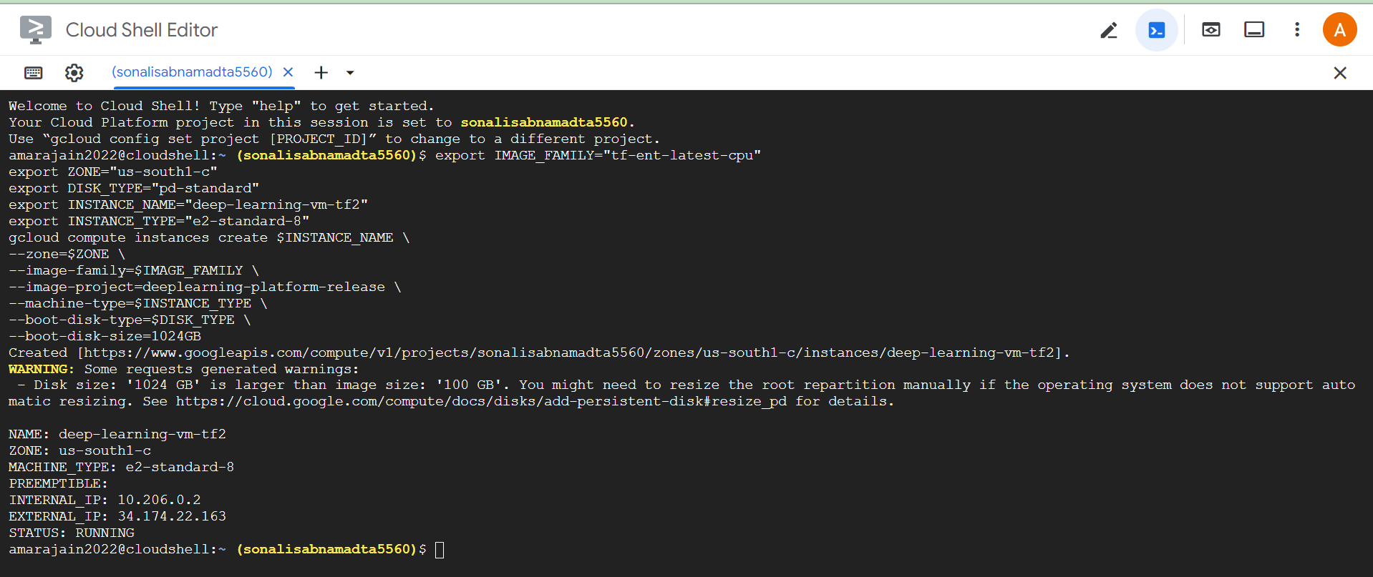
Fig: VM creation command executed successfully
- The VM has successfully started as shown in the below screenshot
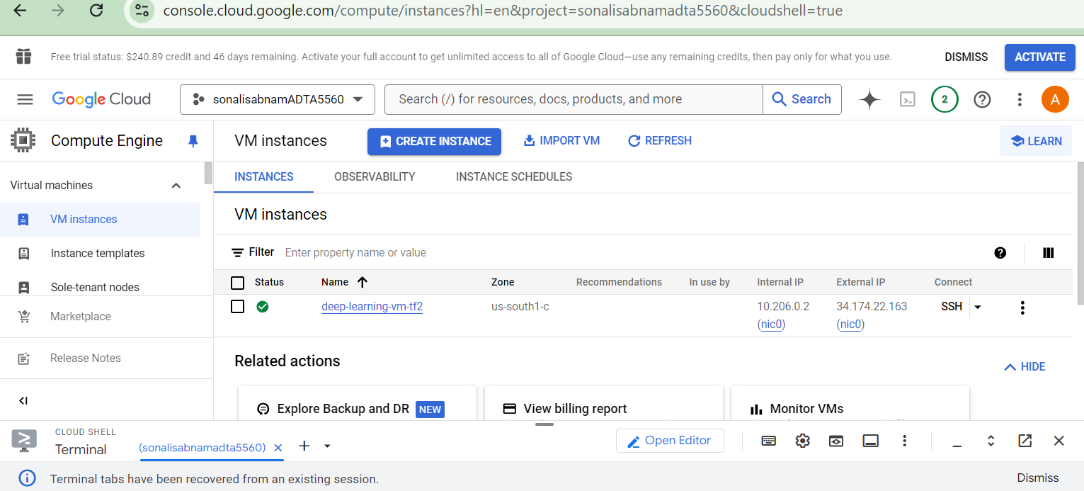
Fig: VM running successfully
- Click on the VM and scroll down to the Boot Disk section to verify the TensorFlow version ss shown in the below screenshot.
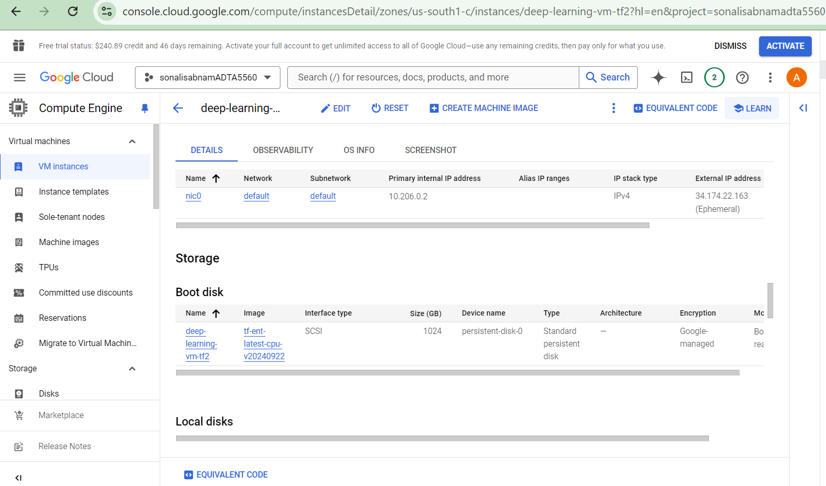
Fig: tensorflow version of the deep learning VM
Cloud SDK Tool Setup
Objective: To setup the cloud SDK tool to connect to remote deep learning VM
The below steps are followed to install and connect to the remote VM usin cloud SDK
- Go to the url https://cloud.google.com/sdk/docs/install-sdk
- Select the documentation for the platform
- Download and install in the local computer
- Execute the command “gcloud init”
- Follow the instructions on the screen if the project/account is not selected as per the current work requirement.
- The below screenshot shows the required setup being selected and the SDK is ready to be used.
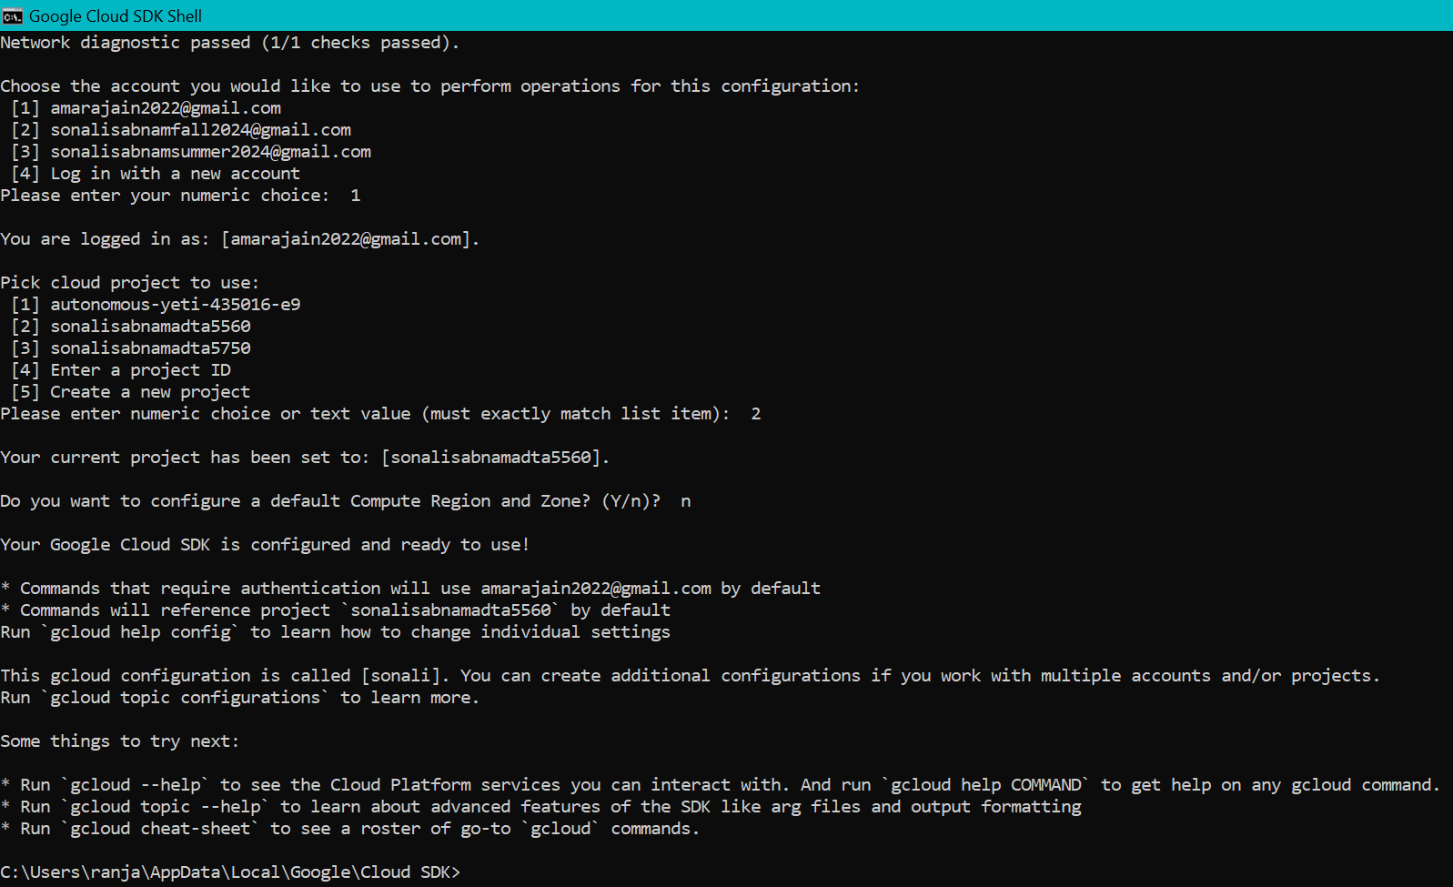
Fig: Cloud SDK is ready to be used.
Conclusion: In this part we successfully created a deep learning VM and installed cloud SDK and made it ready to be used.

PART IV: Connect Explore Remote VM Using SSH (10 Points)
TO-DO
--) Question 4.1:
Based on the lectures, open an SSH connection from the local computer to the remote VM.
Answer: Run the below command
- gcloud compute config-ssh

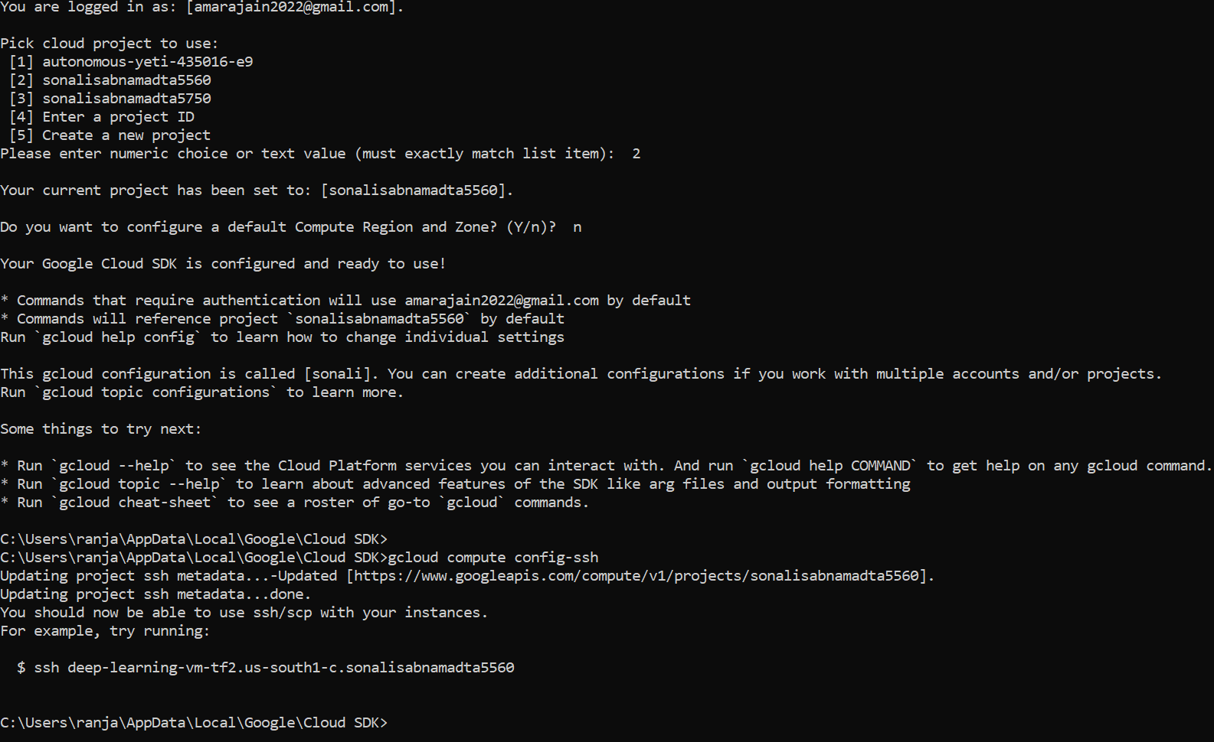
- The keys get created in the local folder
- Run the following command
  - gcloud compute ssh amarajain2022@deep-learning-vm-tf2 --project sonalisabnamadta5560 --zone us-south1-c
- A new putty shell opens up as shown in the below screenshot.
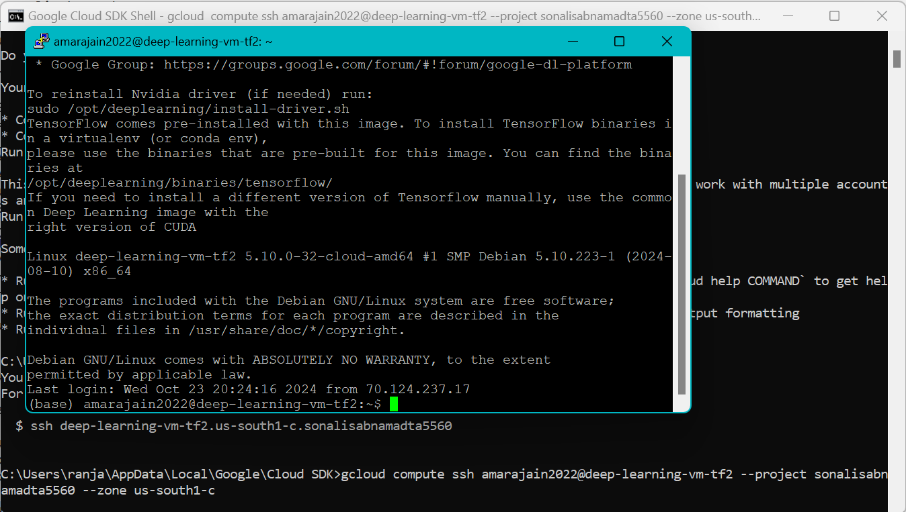
- With this we successfully done ssh to the instance

--) Question 4.2:
Using the basic Linux command lines to explore the contents of the home directory
Answer: Type the below commands
- “pwd”
- The below screenshot shows the commands executed successfully
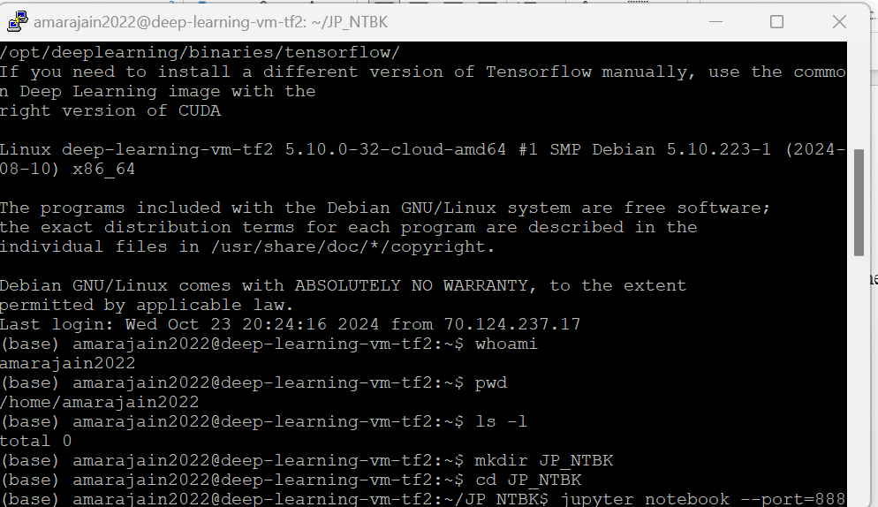

--) Question 4.3:
Create a new sub-folder named “JPTR_NTBK” under the home directory
Answer: Execute the below commands
- “mkdir JP_NTBK”


--) Question 4.4:
Change the current directory to the newly created folder
Answer: Run the below command
- “cd JP_NTBK”


PART V: Start and Connect to Jupyter Notebook in Remote VM (30 Points)
TO-DO
--) Question 5.1:
Based on the lectures, start the Jupyter Notebook server in the remote virtual machine.
Answer: Run the below commands to start the Jupyter notebook
- jupyter notebook --port=8888

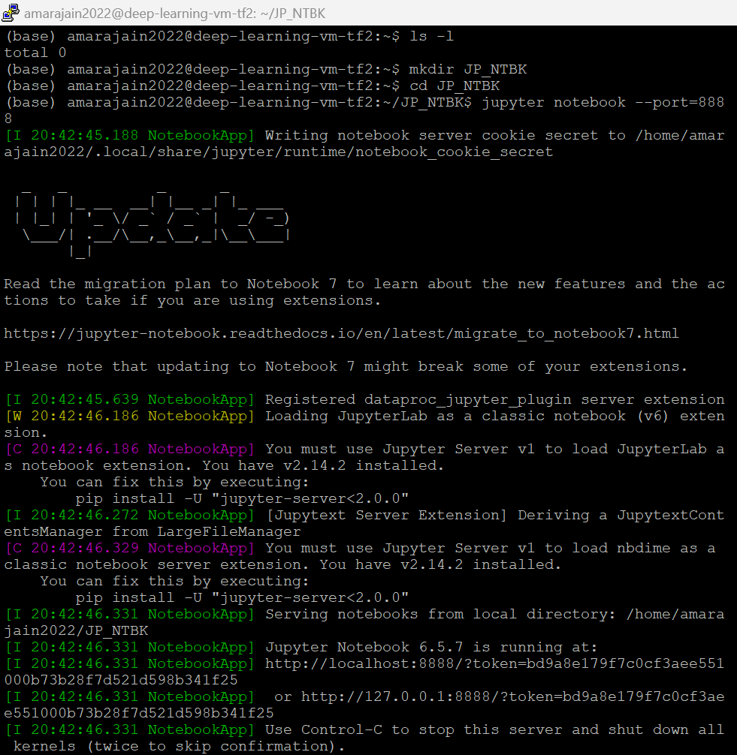
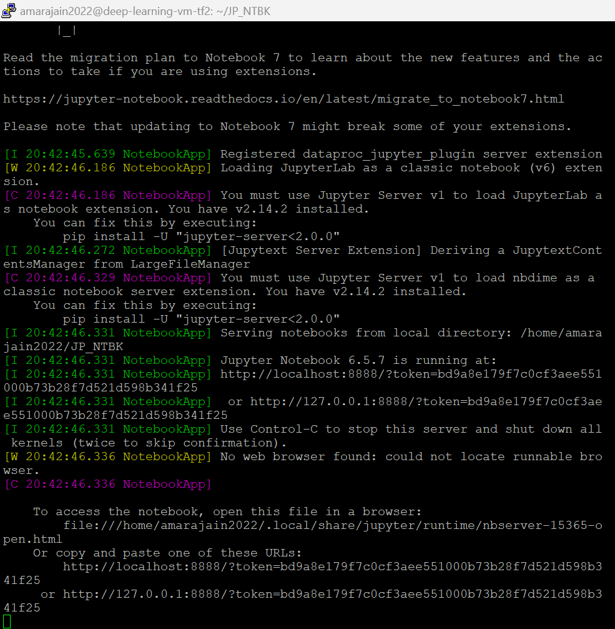
--) Question 5.2:
Connect to the Jupyter Notebook server in the remote virtual machine (by connecting a Local Computer Port, i.e., 8000, to the Remote Server Port, i.e., 8888)
Answer: Follow the below steps to connect to the Jupyter Notebook server in the remote virtual machine.
- Copy the localhost url generated in the previous step and paste it in a notepad
- To forward a local port to the Port 8888 in GCP Remote VM follow the below steps
  - Start a new cloud sdk terminal and run the below command
    - gcloud compute ssh sonalisabnamsummer2024@deep-learning-vm-example --project sonalisabnamadta5550 --zone us-south1-c -- -L 8000:localhost:8888
  - another putty window opens up as shown in the below screenshot

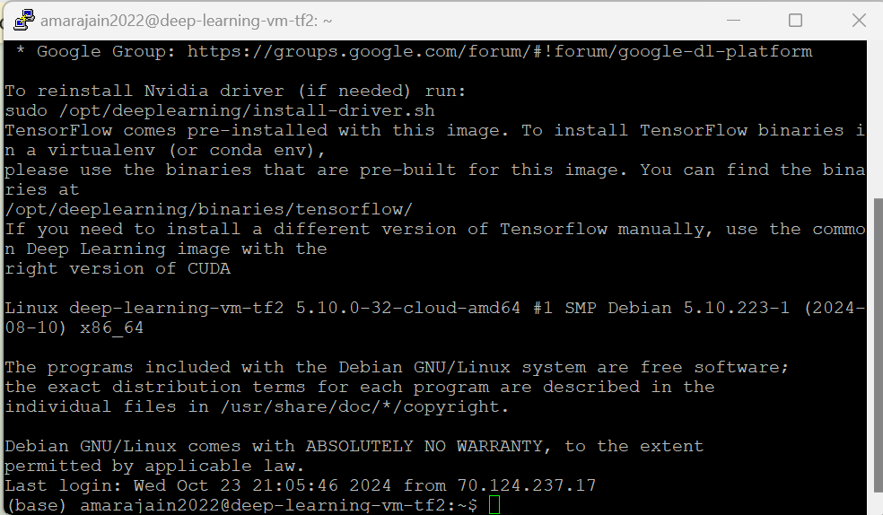

--) Question 5.3:
Access and open Jupyter Notebook that is currently running in the Remote Server (in a browser on the local computer)
Answer: Open a browser and type the below url
- http://localhost:8000
- Now provide the token generated in the previous step
- The jupyter notebook opens up as displayed in the below screenshot.
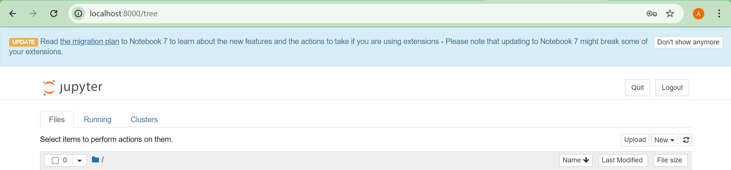
- Stop the deep learning VM once all the steps are completed and verified.

PART VI: History of AI and Big Data (20 Points)
--) The start of AI
--) The periods in which AI seemed to be stalled for many years and WHY?
--) The recent significant achievements, especially in the deep learning area, and the role of Big Data.

Introduction
As per the lecture slides, AI is the theory and development of computer systems able to perform tasks normally requiring human intelligence, such as visual perception, speech recognition, decision-making, and translation between languages.
The Start of AI
The concept of AI was introduced by John McCarthy with Marvin Minsky, Allen Newell and Herbert A. Simon. McCarthy coined the term "artificial intelligence" in 1955.
He also organized the famous Dartmouth Conference in Summer 1956 which marked the beginning of AI as a field.
McCulloch-Pitts neuron model was presented in 1943 and it took inspiration from the human brain cell called the neuron.
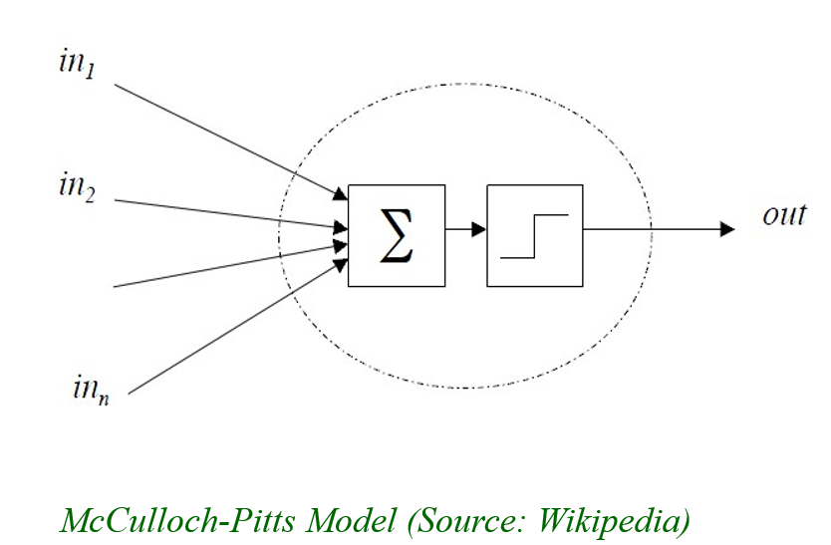
Figure: Waves of AI
(Source: course material-ai_dl_deep_learning_modern_AI_approach.pdf)
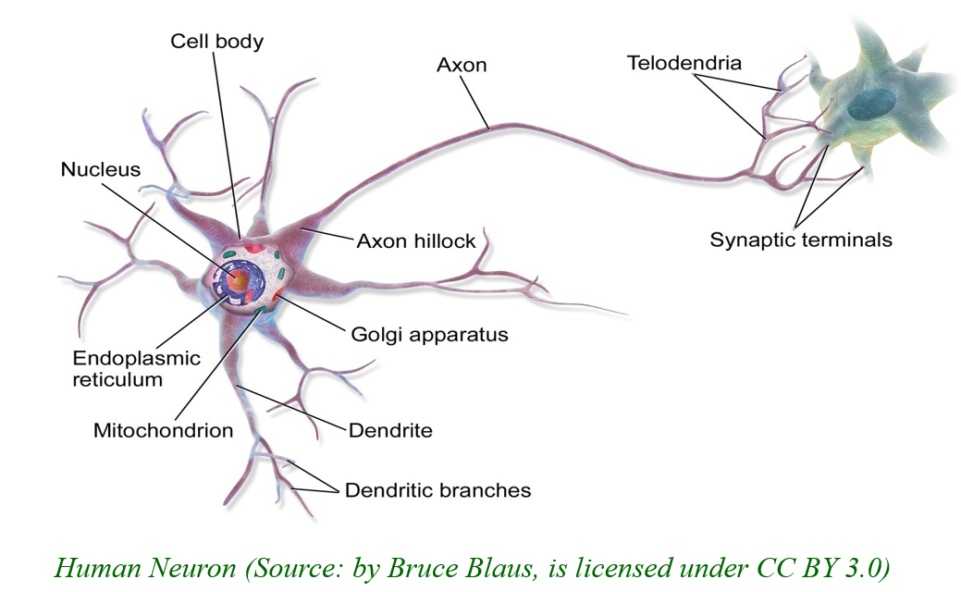
Figure: Human Neuron
(Source: course material- ai_dl_deep_learning_modern_AI_approach.pdf)
The three waves of AI
The first wave of AI started in 1958 with perceptrons and was observed till 1969.
The second wave started in 1970 marked significant progress with backpropagation models and LSTM and OCR and lasted till 1998.
There was a slow down in the AI wave from 1998 to 2006 and the there were no major developments primarily due to lack of compute power and infrastructure. Availability of Large data sets and reliable data storage was also a concern. The AI models needed to be trained on large data sets. The underlying infrastructure for making these datasets available to be used as training data was not readily available.
The third wave started in the year 2006 with Deep learning. It was fuelled by big data and made ground-breaking developments in the field of AI. Large language models and conversational AI are the major milestones of the third wave. riding on the availability of GPUs enabling massive compute power and big data and cloud proving the required infrastructure to handle the massive datasets.
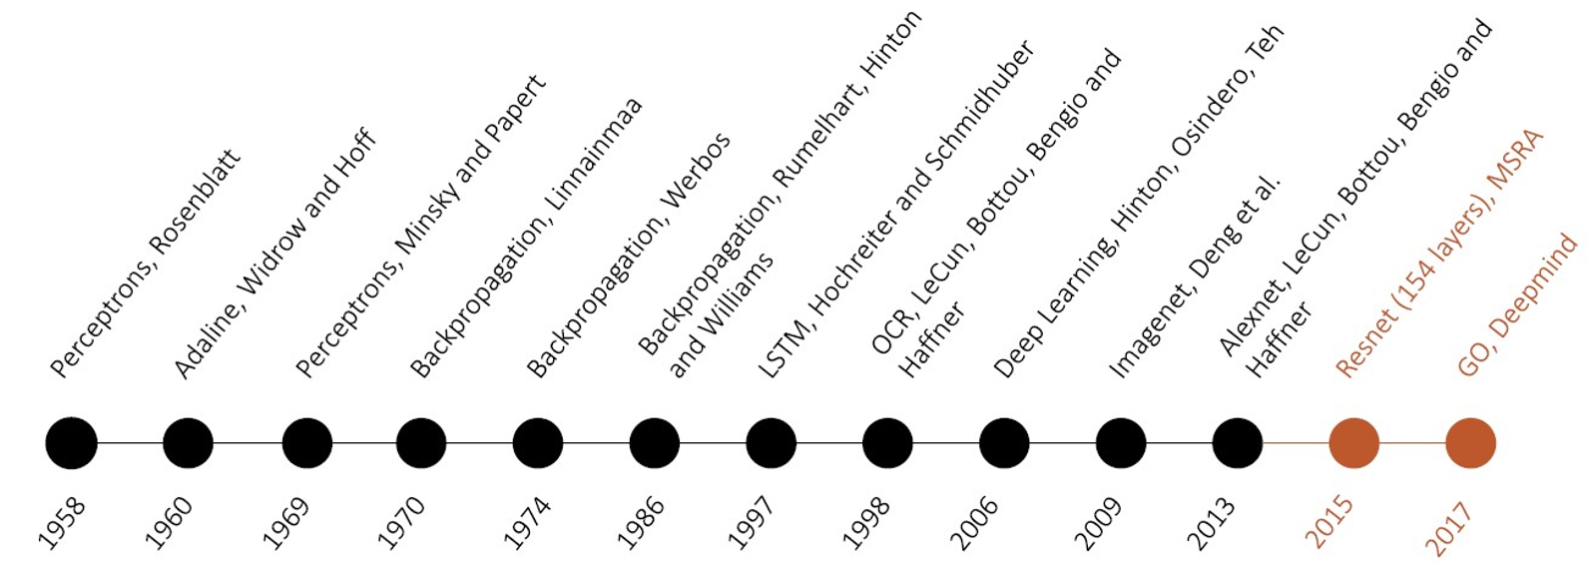
Figure: Waves of AI
(Source: course material: ai_dl_deep_learning_modern_AI_approach.pdf)
Achievements in the Deep learning area and the role of big data
The third wave of AI is riding on GPUs, enabling massive compute power and big data and cloud proving the required infrastructure to handle the massive datasets. The deep learning models need to be trained on big data to get the appropriate results. Big data technologies like Hadoop ecosystem and the cloud services laid foundations for the required infrastructure for successfully training these complex networks. The below figure shows how amount of data significantly improved the performance of Deep Learning.
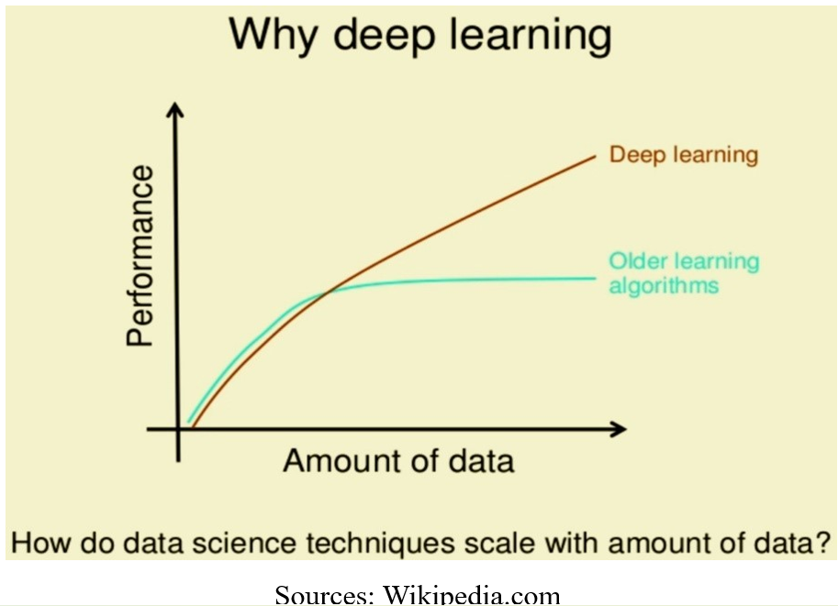
Figure: Amount of Data and the performance of Deep Learning
(Source: course material: ai_dl_deep_learning_modern_AI_approach.pdf)

